**[ Question No. 3]**

Use any map api to draw the Los Angeles’ subway network.

**Development Environment:**

Text Editor: Microsoft Visual Studio Code

Browser: Mozilla Firefox v105.0(64-bit) with Developer Tools for Debugging

Maps API: <https://developer.tomtom.com/map-display-api/>

Los Angeles Subway Stations Information API: <https://geohub.lacity.org/datasets/lahub::metro-rail-lines-stops/about>

Los Angeles Subway Network Route Data: <https://www.metro.net/riding/schedules/> , <https://gitlab.com/LACMTA/gtfs_rail>

**How To View the Map:**

Open the LA_Subway.html using any browser.

A page like below should be displayed:

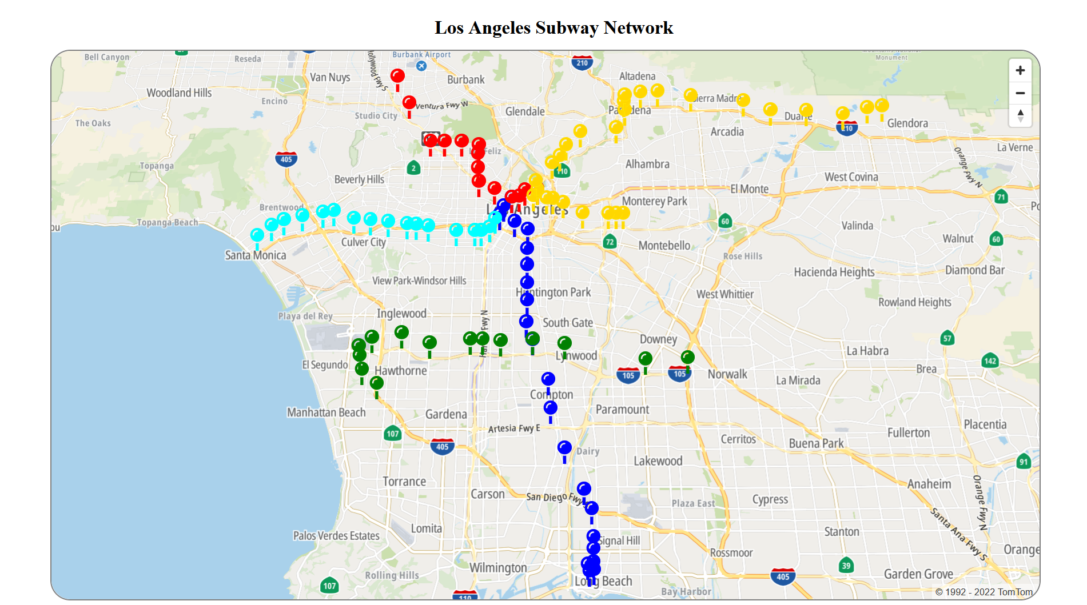

Node: Here tomtom API is accessed using a public key used in their documentation. Incase the map is not displayed, grab a tomtom api key by registering on tomtom (<https://developer.tomtom.com/how-to-get-tomtom-api-key>) and replace it with the public key in LA_Subway.html